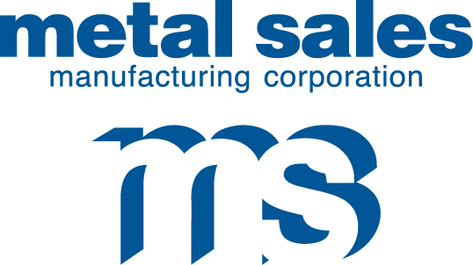

7800 State Road 60
Sellersburg, IN 47172
Phone: 800.999.7777
812.246.1866
Fax: 812.246.0893
www.metalsales.us.com

Metallic Waiver Acknowledgement

Date: Click here to enter a date.

Project ID/SO Number:

Project Name:

Click here to enter text. has requested Metal Sales Manufacturing Corporation (MSMC) produce Click here to enter text.

MSMC needs you to be aware that metallic paint systems are not intended to be mixed in wall/roof panel applications due to potential variations in sheen presentation.

The replacement panel requested above will not be produced out of the same batch of coil from which the original order was produced. This may result in a variation in presentation.

By signing this form, you acknowledge an understanding of potential variation. You acknowledge that all parties concerned in this transaction have been notified, including the end user, that the potential for sheen variation does exist and that this sheen variation is not reason for production rejection and/or return of product.

Company Name: __________________________________

PO#: __________________

Printed Name: ____________________________________

Title: _______________________________

Signature: _____________________________________

Date: ___________________

Contact for Questions or Concerns

CIA Sellersburg Hub
E-Mail: CIASellersburg@metalsales.us.com
Phone: (812)-748-8058

Individual Highlights:
Inside Story 2
Inside Story 3
Inside Story 4
Inside Story 5
Inside Story 6
Inside Story 7
Last Story 8

Special Interest Articles:

- Briefly highlight your point of interest here.
- Briefly highlight your point of interest here.
- Briefly highlight your point of interest here.

